Pan de Vida Retreat “I am the Bread of Life” Jn. 6:35

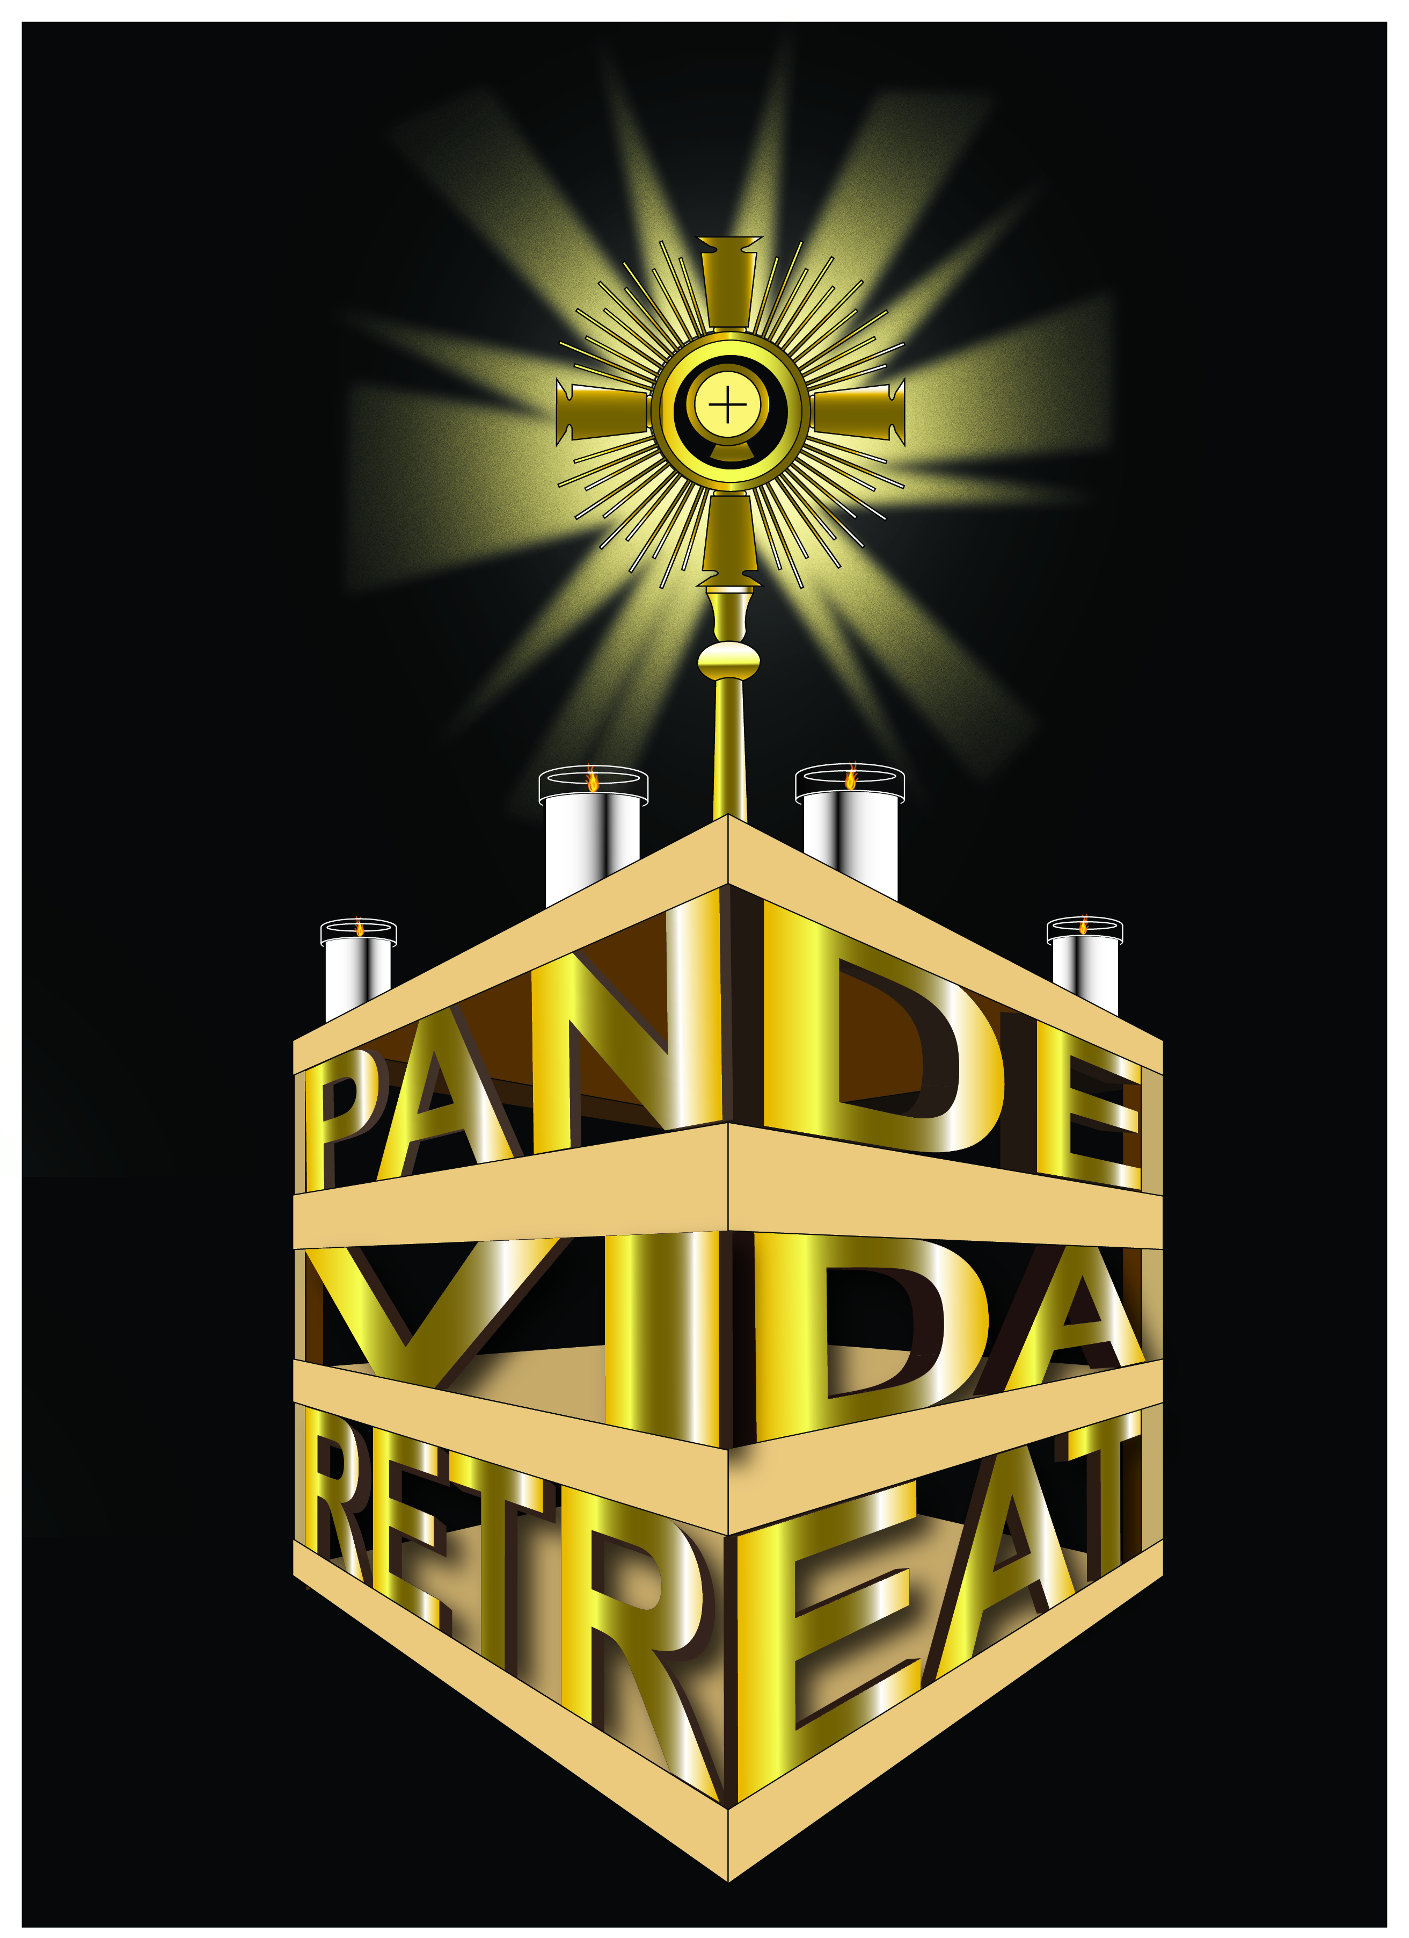

Friday

6:15 P.M. Music

6:30 Welcome/Rosary

7:00 Mass - A Retreat with Jesus

8:15 Break

8:45 Exposition – Talk – (Adoration and the Real Presence)

“I am the bread of Life” Jn 6:35

9:30 Music, Meditation, and Adoration

10:00 Closing

Saturday

9:00 A.M. Music

9:15 Morning Prayer

9:30 Talk – Who is Jesus Christ?

10:15 Workshops

11:00 Short Break

11:15 Music, Testimonies

12:15 P.M. Lunch

1:45 Talk – Examination of Conscience and the Sacrament of Reconciliation

“I Will Not Reject Anyone Who Comes to Me” Jn 6:37

2:30 Workshops

3:15 Break

3:45 Music, Chaplet of Divine Mercy

4:15 International Rosary, Reposition of the Blessed Sacrament, Mass

4:45 Mass - Homily – The Eucharist and the Paschal Mystery

“This Is the Bread That Comes Down From Heaven” Jn 6:58

6:00 Dinner

7:30 Talk – Reconciliation: Gift of the Holy Spirit

“It Is the Spirit That Gives Life, the Flesh Has Nothing to Offer” Jn 6:63

8:15 Music, Meditation, and Adoration

9:00 Eucharistic Prayer Service

10:00 Closing

Sunday

8:30 A.M. Music

8:45 Morning Prayer

9:00 Talk – Mary, Star of Evangelization

“Do Whatever He Tells You” Jn 2:5

9:30 Rosary

10:00 Short Break

10:30 Benediction and Reposition of the Blessed Sacrament

10:45 Crowning of Mary

11:00 Mass, Homily – Witnessing to Christ (Evangelization)

“ The Words I Have Spoken Are Spirit and Life” Jn 6:63

12:15 Testimonies

1:00 Closing

